Scoring in Alice
First, click the “Add Objects” button to open the object tabs.
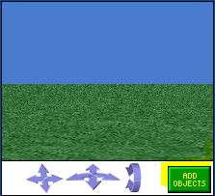
Next scroll left to the “Add 3D Text” button.
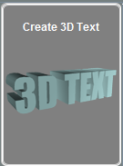
When it opens, type down anything you want, it will change to a number later.
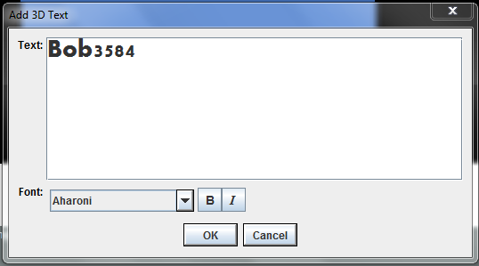
If you want, you can change the font to one of several different styles.
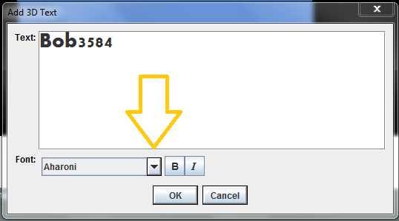
Next click “OK”.
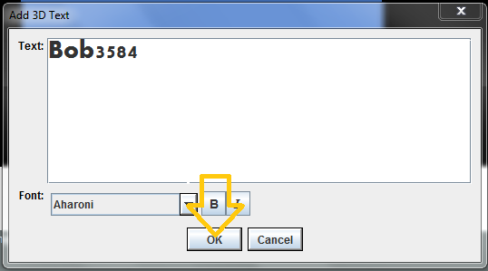
Now you will have your 3D text on the screen.
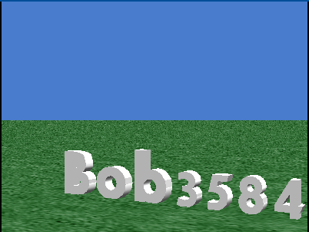
Now go to the tab called “” in the objet tree.
Now, click on the tab labeled “Properties”.
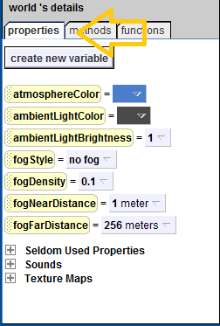
Click on “”.
Make sure “” is selected.
Set the name to “Number”
Click “OK”.
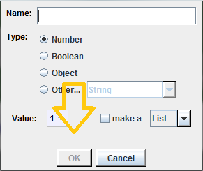
Number
Next click on the “” tab on the object tree.
Next click on the “Methods” tab.
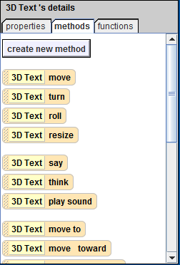
Click “Create New Method”.
When the window comes up, name it “Score”.
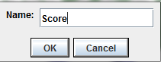
Make sure the tab “3D Text.Score” is open.
Now go to the tab labeled “Properties” under “3D Text”.
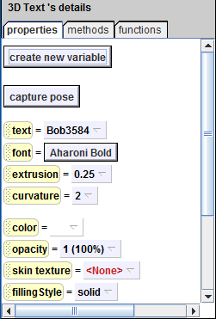
Click and drag the “” tab onto the “”.
Tell it to set “”.
Click on the “” tab.
Open the “Functions” tab.
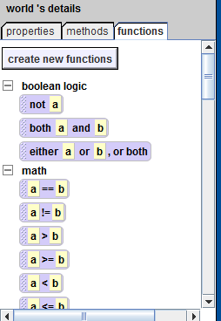
Scroll down till you see a button labeled “” and drag it onto the part labeled “Default String” on “”.
Choose on the scroll down menu “Number” (“”).
Scroll down to the button labeled “” and drag it onto “World.Number”.
When the pop-up menu comes up, roll the mouse over the tab labeled “Expressions” and click on the tab labeled “World.Number”.
Next, drag “” to “”.
Now drag “” inside the “”.
From the properties tab, drag “” into the purple “”, and select “ Increment by 1”.
Go to the events section and click “”.
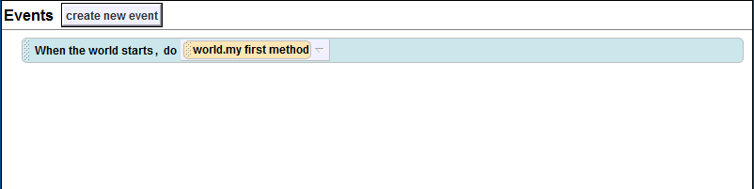
When the pop-up menu apears, click “When the mouse is clicked on something”.
When this “ (that screenshot)” comes up, drag the “Do together” onto the “”””” tab.
Now delete “”.
Set “” to “0”.
Lastly, click “”.
Every time you click, it will increase the number.
This can be edited to fit almost any scenario.
Thanks for reading!

