Collisions in Alice
First open a new world.
Then click on “”.
When it opens up the item display bar, scroll right until you see “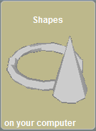” and click on it.
When it opens, insert two of any type of shape, I will be using cubes (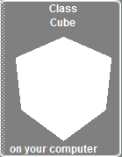).
Your screen should look like this “”.
Click “”.
Now go to the events section “”.
Click on “” and choose “Let the Arrow Keys Move Subject”.
Click on “”, and choose “Cube” (or whatever you inserted).
Now if you click “”, you will see that the arrow keys will control the cube.
Right click on “” and choose “Change to” then click “While the World is Running”.
Go to the object tree (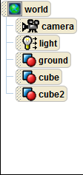) and click on “World”.
Next, go to the action bar “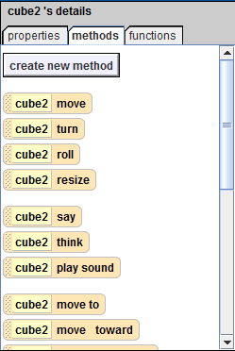” and drag “” onto”<None>” next to “During” in “”
Now, go to the object tree, and click on “Cube2” (or the other object you inserted)
Go to the action bar, and click on “Functions”.
Click and drag “” from the bottom of the screen into “World.my first method and click true, then from the functions tab in the action bar, drag “If [Cube2] is within [Threshold] of [Object]” into “”.
When the choice bar comes up, choose “1 meter”, then “Cube”. The If/Then should now look like this “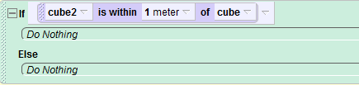”.
Go to the object tree, and click on “Cube”.
Now, click on the “Methods” tab in the action bar.
Drag “” into the If/Then’s top bar () and choose “Move Backwards”, choose “1/2 m.”
Now, click on the “” on “” and choose “Duration” then “Other…” and type down “0 seconds”.
Click on “” again, and choose “Style”, and finally, click “Abruptly”.
Now Click “” and test your world!
If you did it correctly, your cube should not go through cube2, but bounce off.
If you do not get the desired result, go through the tutorial and try to find what happened.
Thanks for reading!

