Bullets in Alice
First, open a new world.
Next, click on “”.
When the explore bar comes up, scroll right until you see “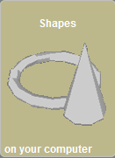”, and click on it.
When the list of shapes comes up, insert two cubes (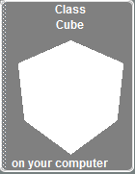).
Go to the object tree (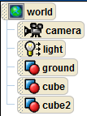), and click on the box labeled “Cube”.
Now, go to the action bar (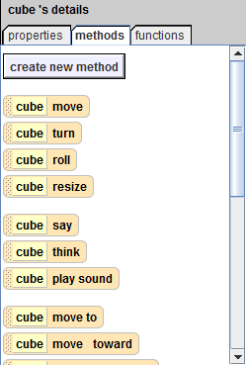), and click on the tab labeled “Properties”.
After that, look in the action bar for the bar labeled “Vehicle”, click on “” and from the scroll down menu, choose “Cube2”.
Now Cube will follow cube2 exactly.
Next, click on “”.
Go to the Functions window (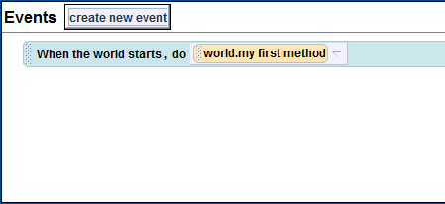), click “”, and choose “Let the Arrow Keys Control Subject”.
Go to “”, click on “” and choose “Cube2” from the scroll down menu.
Then go to the action bar and click on the “Methods” tab.
Drag “” into the “Workspace” (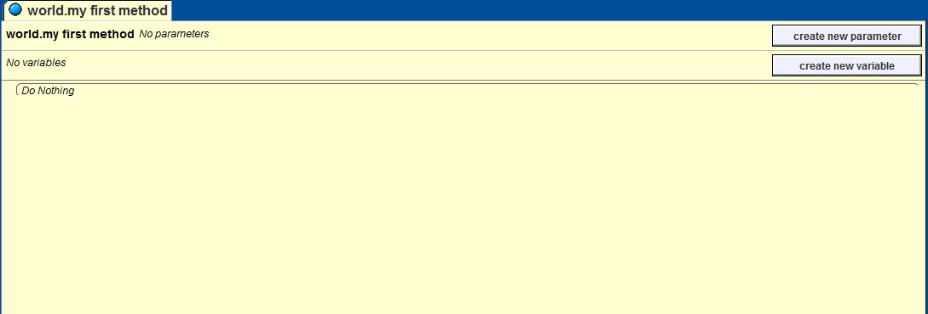), choose “Forward”, then “Other…” type down “100”, and finally, press “”.
Right click on “Cube Move” and choose “Make Copy”.
Go to the copy of “Cube Move”, click on “Forward”, and change it to “Backwards”.
Click on “” again, and choose “When a Key is Typed”.
Go to “”, and click on “”. From the scroll down menu, choose “Space”.
Next, click on “”, and choose “My first method”.
Finally, right click on “”, And choose “Delete”.
Now click “”.
Every time you press space, the cube should move forwards then backwards, and move with cube2.
Thanks for reading!

